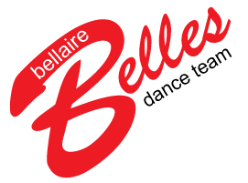

Dear Bellaire Belles Families,

On behalf of the Bellaire Belles Booster Club (BBBC), welcome to the Bellaire Belles! If you are a new family, we are very excited that you are joining us. The Bellaire Belles Dance Team is an excellent way to support Bellaire High School, participate in fun activities, and develop friendships. As a Belle, your child will learn the importance of teamwork and dedication while also having fun and experiencing a camaraderie that is unique to the Belles.

The Belles are very fortunate to have two excellent Directors leading the team. Ms. Denman and Ms. Kastner spend countless hours working with our girls on performances and events, but they cannot do it alone. They rely on the BBBC for organizational and financial support as well as volunteers.

To achieve our goals, we need your volunteer support! There are many ways for each person to help the BBBC in a way that fits your schedule including opportunities to get involved immediately. Please review the Volunteer Information Form in this folder, and let us know how you would like to be involved.

On behalf of Ms. Denman, Ms. Kastner, and the BBBC Board, thank you in advance for your support and participation. We look forward to getting to you know you.

Sincerely,
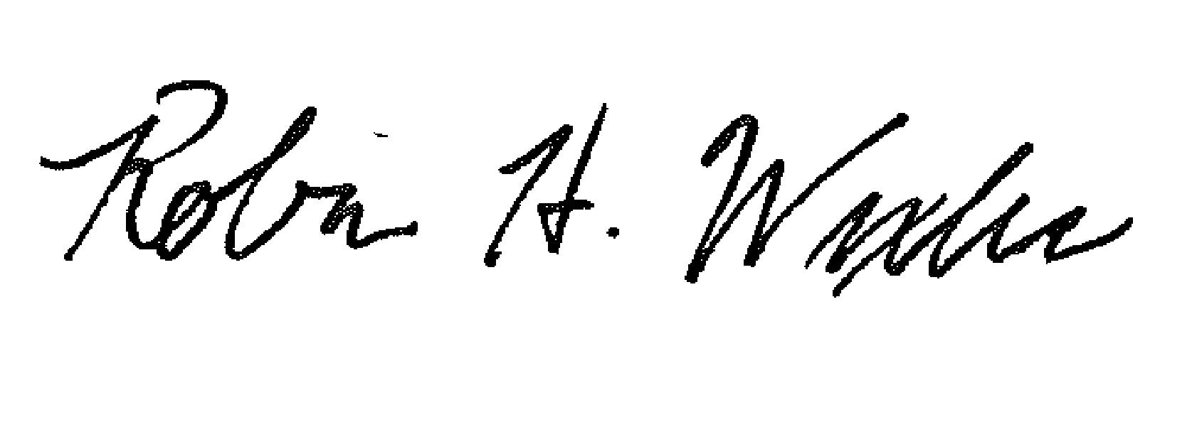
Robin H. Wexler
BBBC President

